**Environmental Pollution and Control: A Case Study Around North Delhi**

**INTRODUCTION**

Environmental pollution is one of the serious problems in most of the megacities of the world, especially in developing countries, which not only experiences a rapid growth of population due to increasing rate of rural urban migration but also industrialization which is accompanied by air, water and vehicular pollution. Exposure to environmental pollution is now an inescapable part of urban life in the world. The phenomenal increase in the population during the last 50 years has led to rapid industrialization and high rate of urbanization, which has created a great deal of pressure on its all natural resources.

Delhi is one of the 10 most polluted cities in the world. In Delhi city the municipal services such as water supply and sanitation, drainage of stormwater; treatment and disposal of waste water; management of solid and hazardous wastes; supply of adequate and safe food and housing are all unable to keep pace with urban growth. All these in turn led to an increase in the pollution levels. Also the unplanned location of industries in and around Delhi followed by improper traffic regulation causes serious pollution problems. However, all these factors together not only lead to deteriorating environmental conditions but also have adverse effects on the health of people. The people in environmental polluted areas are prone to pollution and infected by pollution related diseases. Delhi is perhaps one of the better examples to explain the environmental pollution and measures taken to control it.

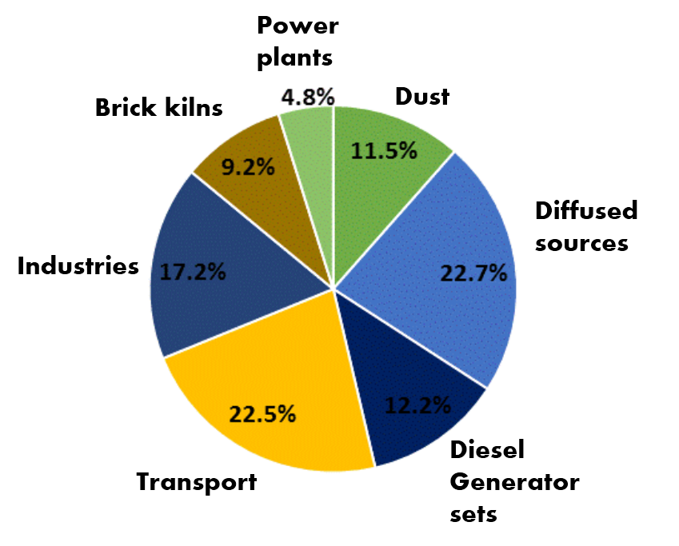

**SOURCES OF POLLUTION**

Main cause of pollution in Delhi is Air pollution which is majorly caused by

* Lack of active monitoring and reaction by authorities.
* Overpopulation.
* Lack of political priority.
* [Motor vehicle emissions](https://en.wikipedia.org/wiki/Motor_vehicle_emissions) are one of the causes of poor air quality.
* Wood-burning fires, fires on agricultural land, exhaust from diesel generators, dust from construction sites, burning garbageand illegal industrial activities.
* Although pollution is at its worst from November to February, Delhi's air misses clean-air standards by a wide margin for much of the year. It is a noxious mix of emissions from its 9 million vehicles, construction dust and burning of waste. On the worst days, the air quality index, a benchmark ranging from zero (good) to 500 (hazardous), exceeds 400.
* The drift/mist emissions from the wet cooling towers are also a source of particulate matter as they are widely used in industry and other sectors for dissipating heat in cooling systems.
* Although Delhi is kerosene free and most of the households use LPG for cooking, the remaining uses wood, crop residue, cow dung, and coal for cooking.
* Heavy metal-rich fire-crackers

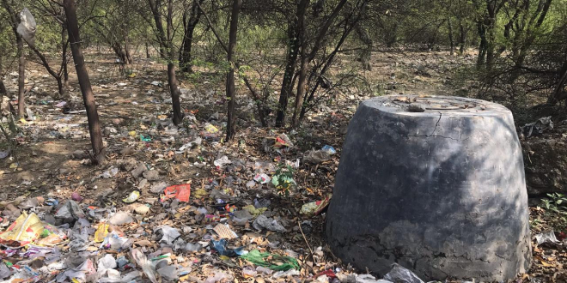

Waste Pollution - The mountain of garbage in the capital is gaining an enormous size, as solid waste management becomes an acute problem especially with the handling of plastic waste. Since everything is dumped together at the landfills, the dumps in Delhi have become to be identified as the largest, least regulated and most hazardous in the world, and it occurs, despite a huge workforce of waste collectors, scrap dealers and recyclers and, a rigorous campaign in operation by various municipal authorities to segregate waste at the source.

Water pollution comes from three main sources: domestic sewage, industrial effluents and runoff from activities such as agriculture. Water pollution from domestic and human wastewater causes many severe water borne diseases. The problem of water pollution due to industries is because of the inadequate measures adapted for effluent treatment than to the intensity of industrial activities. The quantity of sewage and liquid wastes from human settlements and uncontrolled industries generated by Delhi now far exceeds both the city’s wastewater treatment capacity and carrying capacity of its sewers. The water quality is affected due to the inadequate availability of basic facilities and rapidly increasing population.

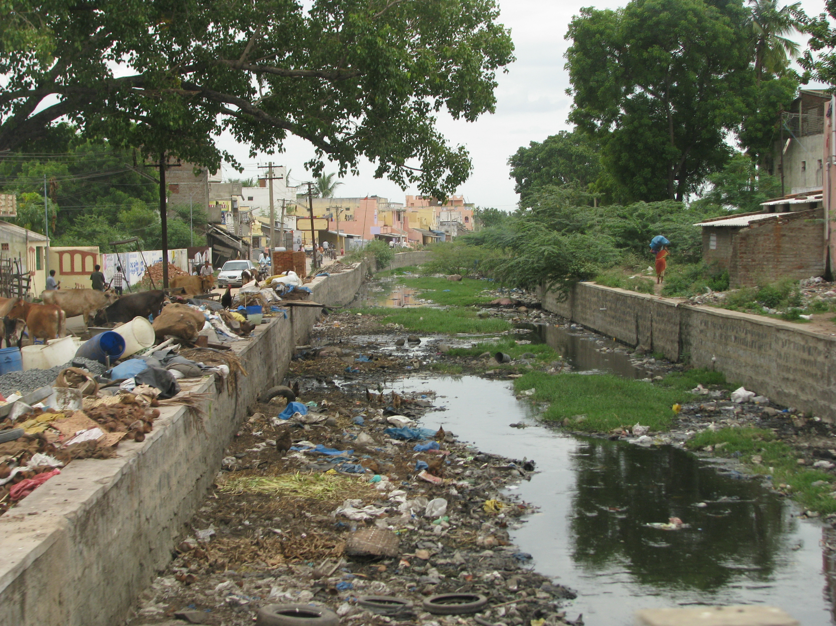In many of the substandard housing colonies, wastewater and garbage denied proper outlets stagnate for long periods slowly and eventually pollute the groundwater. Ground water sources in the vicinity of industrial areas are more prone to contamination, especially by toxic elements in the absence of an adequate sewage system.

**STEPS TAKEN BY GOVT.**

* On the orders of the Supreme Court in 2016, Delhi became the first state to implement Environment Compensation Charge (ECC). An ECC of 1% will have to be paid for the registration of diesel cars above 2000 cc in Delhi.
* By making e-rickshaws available at a subsidised rate of Rs. 30,000, Delhi has created the largest network of e-rickshaws in the country — promoting clean last mile connectivity.
* Delhi Government also put a ban on construction sites during peak pollution seasons. Heavy fines up to Rs. 8 crores were imposed against violators.
* Delhi’s green cover has increased from around 20.2% in 2015 to 20.6% in 2017 (Forest Survey of India Report 2009- 2017) – an increase of about 1100 hectares.
* We put a complete ban in the use of coal in Delhi. Delhi is the first modular state which has no coal-based power plants.
* By providing 24 hours electricity at subsidised rates, we were successful in making diesel based power generators completely redundant
* As a one of its kind measures, we appointed Environment Marshalls which keep a strong vigilance on garbage burning in Delhi.
* To combat air pollution, we came up with our very own E-Vehicle policy. The policy aims to enable the adoption of electric vehicles easier and make one-fourth of the vehicles to be electric in Delhi by 2023.
* This year we planted 3 Lakh tree saplings and shrubs across the National Capital. Last year, we planted 5 lakh saplings in a day.

**MY TAKE AND CONCLUSIONS**

1. Car pooling: Reduce traffic-based air pollution and congestion by starting car pool lanes for those cars and four wheelers that have three or more passengers to encourage people to go for carpooling.
2. Use bicycles: Mark out bicycle lanes in residential colonies as well as on all roads in Delhi to encourage safe travel by bicycles. Meanwhile, citizens should also be encouraged to use bicycles.
3. Public transport: Encourage greater use of public transport by supporting the Metro, overhead rail and bus services to make it convenient for people to travel by public transport affordably and safely instead of using their own vehicles. Citizens too must shed hang-ups over social status and try to travel by public transport proactively.
4. More CNG vehicles: Encourage use of CNG in motor vehicles as it is a much cleaner fuel than petrol or diesel by considerably reducing the road tax and sales tax on CNG filled cars as compared to petrol and diesel four wheelers.
5. Bigger trucks: Encourage six-axle trucks rather than the typical four-axle ones to increase the payload per truck to reduce the number of trucks on roads. Trucks going to other destinations must not be allowed to pass through Delhi and only use the bypass.
6. Maintenance of roads: Better maintain roads to complexes such as Nehru Place to reduce the time a four wheeler spends on plying on such poor roads.
7. Shared taxis: The transport department should encourage shared taxi services by developing a taxi sharing website and set up taxi stands and cabs to offer reduced fares for shared service. This is other than the facilities Ola and Uber provide.
8. Burning waste: Burning of leaves, old tyres or any items in the open should be made a punishable offence in NCR with a fine of Rs 10,000 per incident as this is a major cause of air pollution. Citizens should be asked to report such incidents to helpline numbers and emails.
9. Solar power: Installation of solar panels should be encouraged at homes, multi-storey buildings and commercial establishments so that decentralised power is generated with suitable subsidies to make it financially viable for all households. The cost of solar panels has come down considerably.
10. Dump sites: Landfills should be better managed by the government to ensure there are no fires there.

Rapid population growth continues to be a matter of concern as it has manifold effects, one of the most important being environmental pollution. With the increasing population, urbanization and industrialization, the transport demand has also increased consequently. Delhi is one of the most polluted cities in the world, caused by vehicular growth and industrial pollution. In order to restore the air quality, Delhi government has taken some measures to such extent as already discussed, and these have helped to reduce the levels of air pollution to a large extent. If such measures are carried out in full swing as the study proves that the days are not far away when pollution in Delhi can be minimized to a great extent. As regards to water pollution, more wastewater treatment plants be established in accordance with the need of time and heavy penalty be imposed on industries disposing off the wastes into the river. Moreover, the landfills are to be properly managed to prevent groundwater contamination. Since, slums are one of the major sources of water pollution proper measures should be taken to facilitate the slums with sewage facilities. There is now high time for giving top priority to control population and pollution of all types. The government should make special efforts to bring about awareness among the people for a collective action to solve this problem. Only legislation may not be able to protect the environment. All citizens and voluntary associations come forward and work together with environment scientists to protect the environment for present and future generation.